**YEAR 11 HUMAN BIOLOGY TEST 5**

**PART A: Multiple Choice Questions (30 marks)**

1. The most vulnerable time for adverse effects on the development of the foetus is during;

a) conception b) the first three months

c) the last three months d) birth.

1. Which of the following reproductive technologies involves the artificial fertilisation of an ovum?

a) In-vitro Fertilisation b) Gamete intrafallopian transfer

c) Intracytoplasmic sperm injection d) surrogacy

1. Which of the following is NOT true of IVF?
2. The success rate decrease with age
3. The sperm fertilises the egg outside of the body
4. The egg is fertilised artificially
5. The woman must be given drugs to stimulate ovulation
6. Between what days in the normal 28 day menstrual cycle is fertilization considered most likely?

a) 0 – 5 b) 6 – 9

c) 12 – 16 d) 19 – 21

1. The hollow ball of cells which is in the uterus three or four days after fertilisation is called the:

a) foetus. b) trophoblast.

c) morula d) blastocyst.

1. The ectoderm is the primary tissue which gives rise to:

a) the digestive system b) muscle, bone and blood vessels.

c) extra-embryonic tissues d) skin and the nervous system.

1. The membrane enclosing the foetus in a fluid filled sac is the:

a) amnion b) allantois

c) chorion d) yolk sac

1. The risk of a child developing which disease below can be minimised by increasing folic acid (or folate) in the expectant mother’s diet (or before the woman becomes pregnant):
2. Spina bifida
3. Cleft palate
4. Down syndrome
5. Foetal alcohol syndrome
6. Amniotic fluid is important by serving as a medium;

**I** for providing nutrients to the embryo

**II** to provide constant temperature surrounding the embryo

**III** to act as a shock absorber for the embryo

a) **I** only. b) **I** and **II** only.

c) **II** and **III** only. d) **I, II** and **III.**

.

1. The gestation period for humans is about:

a) 365 days b) 280 days

c) 28 days d) 4 days

1. What is generally considered maximum, or complete, dilation of the cervix

a) 12cm b) 5cm

b) 7cm d) 10cm

1. The blastocyst is formed after;
2. the third day b) the first day

c) the second week d) the fifth day

1. F.S.H. is a hormone which has the function of;

a) promoting lactation after child-birth.

b) controlling reabsorption of water from kidney tubules.

c) stimulating follicle cells and ensuring the development of a maturing ovum.

d) regulating metabolic rate.

1. Which of the following statements about pregnancy is INCORRECT?
2. During late pregnancy women urinate more often because the expanding uterus exerts pressure on the bladder.
3. The lungs of the foetus are collapsed until birth
4. The chorion is made from the mother’s cells
5. The umbilical vein carries oxygenated blood from the placenta to the foetus.
6. The hormone responsible for maintaining the uterine lining during implantation is

a) progesterone b) oestrogen

c) oxytocin d) luteinising hormone

1. A short time after a baby is born; the "after birth" is expelled. This is the:

a) the membranous bag that contained the baby.

b) wastes produced by the developing foetus.

c) watery fluid called colostrum.

d) placenta and associated foetal membranes.

1. If both sperm ducts (vas deferens) are cut in a process called vasectomy, then:
2. sperm will be produced but not seminal fluid.
3. neither sperm nor male hormones will be produced.
4. Sperm will be produced but male hormones will not.
5. Sperm will not be released but male hormones will be produced.
6. Identical twins are the result of
7. A single ovum fertilised by two sperm.
8. One sperm dividing and fertilising two ova.
9. One fertilised ovum dividing to form two embryos.
10. Two ova fertilised at the same time by two different sperm.
11. Which two structures give rise to the foetal and maternal placenta respectively,

1. amnion and endometrium
2. chorion and endometrium
3. amnion and chorionic villi
4. chorion and chorionic villi
5. The uterine tubes (Fallopian tubes) lead from the ovary to the
6. uterus.
7. vagina.
8. corpus luteum.
9. bladder.
10. The Ectoderm germ Layer gives rise to which of the following structures.

1. entire nervous system
2. dermis of skin
3. cardiac muscle
4. epithelium of lungs
5. Fertilisation is possible for only a brief part of each female cycle because
6. there is only one ovum and many sperm.
7. the corpus luteum degenerates very quickly after ovulation.
8. both live sperm and ovum must be present for fertilisation.
9. spermatozoa are released rhythmically at ovulation.
10. The single cell formed after fertilisation is called
11. an embryo.
12. a foetus.
13. a gamete
14. a zygote.
15. The beginning of each menstrual cycle in a mature human female is
16. when ovulation occurs.
17. the last day of each month.
18. when the egg reaches the uterus.
19. when the lining of the uterus begins to break down.
20. In the diagram of the female reproductive system shown below, fertilisation would occur at the point marked



1. A.
2. C.
3. F.
4. H.
5. After ovulation the empty follicle becomes

a) a corpus luteum.

b) a corpus albicans.

c) a Graafian follicle.

d) scar tissue.

1. If a couple wants to become pregnant using their own sperm and eggs and the male has non motile sperm which of the following Assisted Reproductive technologies would be used to produce a zygote:
   1. Surrogacy
   2. Gemete intrafallopian sperm transfer
   3. Intracytoplasmic sperm injection
   4. Donor egg
2. Which of the following correctly shows the life span of an egg after ovulation, the life span of sperm inside the female reproductive tract and the period over which fertilisation could theoretically occur.

**Life span of egg life span of sperm period available for**

**fertilization**

1. 24 hours 48 hours 72 hours
2. 12 hours 72hours 72 hours
3. 24 hours 72 hours 96 hours
4. 24 hours 72 hours 144 hours
5. The correct labels for the structures marked 1 to 4 on the diagram below are

1

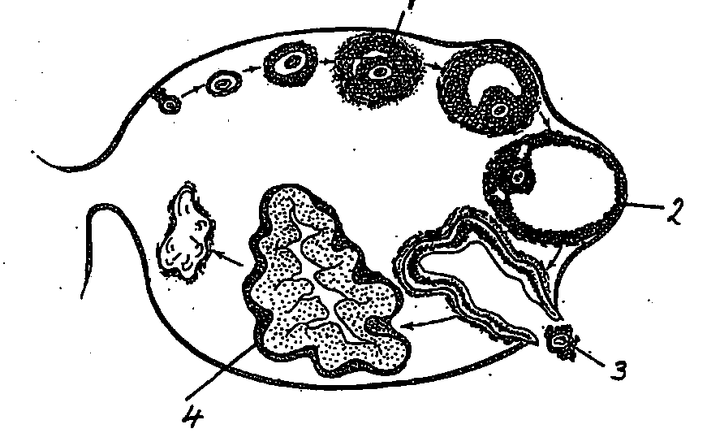

4

3

2

|  |  |  |  |  |
| --- | --- | --- | --- | --- |
|  | **1** | **2** | **3** | **4** |
| a graafian follicle | corpus luteum | ovum | secondary follicle | Graafian follicle |
| b | Graafian follicle | secondary follicle | ovum | corpus albicans |
| c | ovum | secondary follicle | corpus luteum | Graafian follicle |
| d | secondary follicle | Graafian follicle | ovum | corpus luteum |

1. A good example of a genetic disease that can be treated successfully if diagnosed immediately at birth is:
2. Huntington’s disease
3. PKU
4. Sickle-cell anaemia
5. Diptheria

**Human Biology**

Year 11

Test 5 – Reproduction

Answer Booklet

Student Name: _____________

|  |  |  |  |
| --- | --- | --- | --- |
| PART A |  | /30 |  |

|  |  |  |  |
| --- | --- | --- | --- |
| PART B |  | /40 |  |

|  |  |  |  |
| --- | --- | --- | --- |
| TOTAL |  | /70 |  |

|  |  |
| --- | --- |
| **GENERAL INSTRUCTIONS**   * Time Allowed: 50 minutes * Write using a black or blue pen * You may use pencil to draw diagrams * Attempt ALL questions * Scientific calculators may be used | **PART A 30 Marks**  Consists of 30 Multiple choice questions  **PART B 40 Marks**  Consists of 6 short answer questions |

**MULTIPLE CHOICE ANSWER SHEET**

**PART A**

* Use a pencil to fill in the correct letter as shown



|  |  |  |
| --- | --- | --- |
|  |  |  |
| 1 [A] [B] [C] [D] | 11 [A] [B] [C] [D] | 21 [A] [B] [C] [D] |
| 2 [A] [B] [C] [D] | 12 [A] [B] [C] [D] | 22 [A] [B] [C] [D] |
| 3 [A] [B] [C] [D] | 13 [A] [B] [C] [D] | 23 [A] [B] [C] [D] |
| 4 [A] [B] [C] [D] | 14 [A] [B] [C] [D] | 24 [A] [B] [C] [D] |
| 5 [A] [B] [C] [D] | 15 [A] [B] [C] [D] | 25 [A] [B] [C] [D] |
| 6 [A] [B] [C] [D] | 16 [A] [B] [C] [D] | 26 [A] [B] [C] [D] |
| 7 [A] [B] [C] [D] | 17 [A] [B] [C] [D] | 27 [A] [B] [C] [D] |
| 8 [A] [B] [C] [D] | 18 [A] [B] [C] [D] | 28 [A] [B] [C] [D] |
| 9 [A] [B] [C] [D] | 19 [A] [B] [C] [D] | 29 [A] [B] [C] [D] |
| 10 [A] [B] [C] [D] | 20 [A] [B] [C] [D] | 30 [A] [B] [C] [D] |

**YEAR 11 HUMAN BIOLOGY – TEST 5**

**PART B: Short answer questions (40 marks)**

1. Use the diagram below to answer the following questions.



1. Identify the structure labelled: (4 marks)
   1. F____________________________________
   2. B____________________________________
   3. C____________________________________
   4. G____________________________________
2. Name and describe the function of each of the male accessory glands.

(6 marks)

___________________________________________________________________________________________________________________________________________________________________________________________________________________________________________________________________________________________________________________________________________________________________________________________________________________________________________________________________________________________________

1. It can be very important to screen an unborn child for various genetic diseases such as Huntington’s disease and Spina bifida. Briefly describe three techniques used to genetically screen embryos. ( 5 marks)

______________________________________________________________________________________________________________________________________________________________________________________________________________________________________________________________________________________________________________________________________________________________________________________________________________________________

1. During pregnancy it is very important to avoid exposure to teratogens. Some examples of teratogens are infections such as rubella and chemicals such as thalidomide. Define teratogen and give three other examples of teratogens. (4 marks)

______________________________________________________________________________________________________________________________________________________________________________________________________________________________________________________________________________________________________________________________________________________________________________________________________________________________

1. Infertility refers to the biological inability of a person to contribute to conception. Some types of infertility can be overcome with in-vitro fertilization (IVF). Explain the procedure used in IVF.

(5 marks)

__________________________________________________________________________________________________________________________________________________________________________________________________________________________________________________________________________________________________________________________________________________________________________________________________________________________________________________________________________________________________________________________________________________________________________________________________________________________________________________________________________________________________________________

1. Complete the table below for the female reproductive system: (8 marks)

|  |  |  |  |
| --- | --- | --- | --- |
| Hormone | Where is it produced | Organ targeted | Effect |
| FSH | *Pituitary Gland* |  |  |
| LH |  | *Ovaries* |  |
| Oestrogen |  |  | *Stimulate the growth and repair of the endometrium.*  *Produces secondary female characteristics* |
| Progesterone |  | *Endometrium of the uterus* |  |

1. The diagram below illustrates the circulation of a foetus during pregnancy.

State **four** ways in which foetal circulation differs from normal adult circulation and label these on the diagram below.

For each difference, give the reason for the difference.

(8 marks)



